ASR 5787 – eTracker Dashboard – retrieve by Plan Pick up date.

Changes: e-tracker dashboard , the report will be based on **Plan Pickup date** instead of ETD.

( Plan pickup = 2 days before ETD )

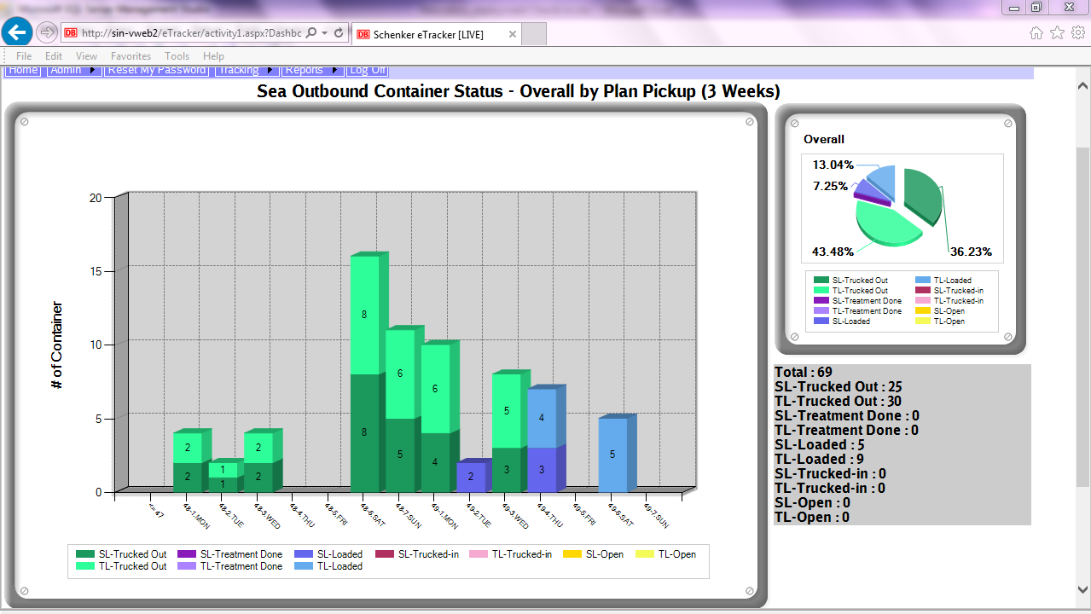

On 5 Dec 2015, Sat: ( 49-6.Sat)

